Metropolitan Detention Center:
Preliminary Review of Length of Stay for Inmates in Segregation 6 and 7
At the Metropolitan Detention Center (MDC), Segregation & Intake (S & I) 6 and 7 are pods designated to be used for detoxification, which includes opiates. To estimate the time spent by an inmate in these pods, the population of inmates in these pods was taken for the last day of the month for January, February, March, and April of 2017. The subsequent cell movements were reviewed to determine at what point the inmate was moved out of the pod and the length of stay (LOS) in the pod was calculated.
Two inmates were in the sample more than once and the duplicate entries were removed. During the 4-month period there were 206 unique inmates in custody at the end of the month in the two pods. There were 41 inmates in the pods on January 31st, 52 inmates on February 28th, 60 on March 31st, and 55 on April 30th. Any movements between cells or between the pods was considered part of the same stay in the detox pod. One inmate was still in the segregation pod as of May 30, 2017 so was excluded from the LOS calculations.
For the 205 inmates in custody in S & I 6 and 7 at the end of the month from January through April of 2017, the average LOS in these pods was 5.6 days and ranged from .62 days to 180.7 days. The median LOS was 2.8 days, so half of the inmates were in less than 2.8 days and half of them were in more than 2.8 days.
During the cell location review, in S & I 6 and 7 a series of cell locations came up repeatedly for a subset of inmates, indicated by a B in pod 6 and DR in pod 7. In addition, inmates may stay in these pods for an extended period of time and are sometimes reclassified from “Unclassified” to “General Population” or “Administrative Seg”. Based on the presence of these cell locations, the LOS, the change in classifications, and past conversations with the MDC staff on the use of segregation it is possible that these pods may house inmates who are not detoxing at some points in time and inmates may remain in these pods for an unknown period of time following detoxification. If the cell locations B and DR and intended to indicate inmates who are detoxing, the LOS in these cells may more accurately indicate the LOS for these individuals.
There were 159 inmates with a B or DR cell location out of the entire group of 205 inmates. The average LOS was 3 days and ranged from .2 days to 8.9 day. The median LOS was 2.7 days for the 159 people in this group.
Of the 206 inmates in the total sample, 172 were released and the remaining 34 were still in custody. The release information was reviewed and categorized based on the dates of “release” by case and by date. Of those released, RORs accounted for 46 (27%) and those who bonded out accounted for another 37 (21%). An additional 29 (17%) were transferred to the New Mexico Corrections Department (NMCD) or another agency. There were 21 people (12%) who got credit for time served and another 15 (9%) who were nolle’d. There were 9 (5%) people ordered released, 8 dismissals (5%), 4 releases to a third party (2%), and 3 of some other release type (2%).
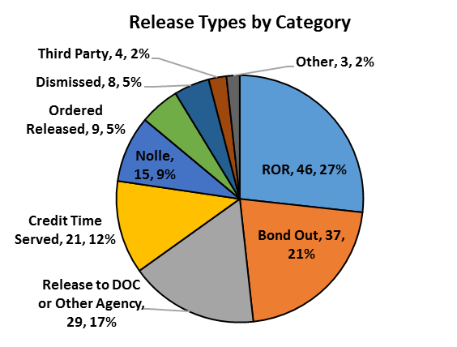
Information available in the MDC’s information system is not sufficient to adequately describe the subset of inmates in the two detoxification pods who are opiate users and may be eligible for methadone induction.
To more completely describe the target population, we will need access to information detailing whether inmates were detoxing from opiates or had an opiate addiction. We also need to better understand how long individuals need to be in MDC to become eligible for methadone induction.
It may also be possible to provide an estimate from two other sources. First, a review of data collected by Correct Care Solutions (CCS) from the Receiving Screening form administered at booking to all those arriving at MDC for booking could be completed. Those who self-report using opiates not prescribed by a physician could be compared to inmates who become clients in the Recovery Services of New Mexico methadone treatment program at MDC. Inmates who are not clients in the methadone treatment program could be eligible for methadone induction. Second, CCS maintains a daily master list of individuals who are clients. For each client CCS includes diagnoses and this includes “opiate dependence”. On May 26, 2017 91 (15.1%) of the 601 individuals on the CCS Psychiatric Services Unit (PSU) caseload had an opiate dependence diagnosis. They may also have had other diagnoses.

In some instances, there were a large number of cell movements within the pod.
The latest date of release was used. If there was more than one release type on the same date, the more stringent release type or that which indicates that the court still had jurisdiction was used. For example, if an individual bonded out on one case and ROR on another case the same day, they were categorized under a bond. A transfer to DOC or another agency was considered the highest ranking release type.

